# Durable Furnitures

Noir

## Estelle Bar Stool

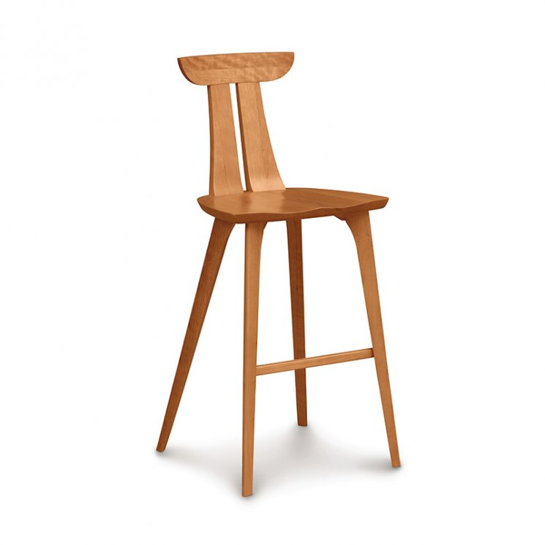

Copeland's high end Estelle Bar Stool features the essence of mid-century modern, minimalist design. Sculpted in solid American Cherry wood, this unique bar stool has a slender, vertically split back and finely sculpted seat for the ultimate in comfort. Rounded, angular tapered legs complete the stunning contemporary design. Available in natural cherry (no stain) or windsor cherry, autumn cherry, cognac cherry, saddle cherry or smoke cherry. Best in its class of authentic custom fine dining furniture, this retro-styled cherry wood stool is destined to be the focal point of your upscale modern kitchen!